NAME: CH HARSHITHA
HALL TICKET NO: 2503B0135
Q1. Generate Python code for the Fibonacci sequence with Cursor AI. Refine your prompts to handle only positive integers and record the changes and outcomes.
Prompt-1: Generate Python code for the Fibonacci sequence with n terms
Prompt-2: Update the Fibonacci code to validate that n is a positive integer. If not, raise a Value Error.
Prompt-3: Take input from user.
CODE:
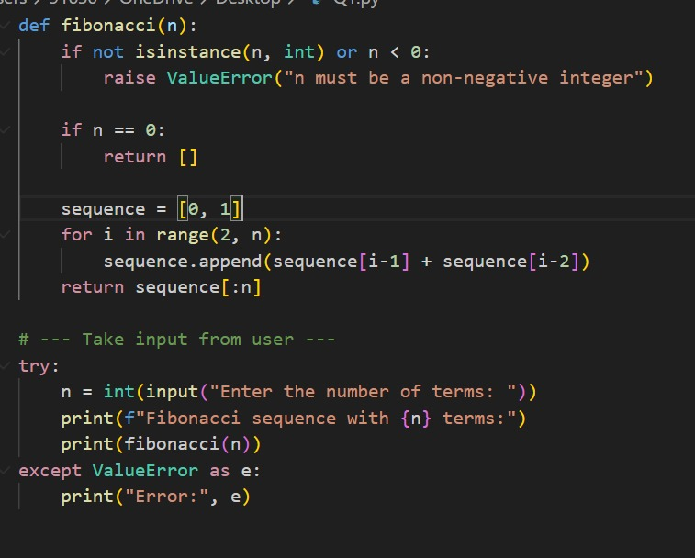

OUTPUT:
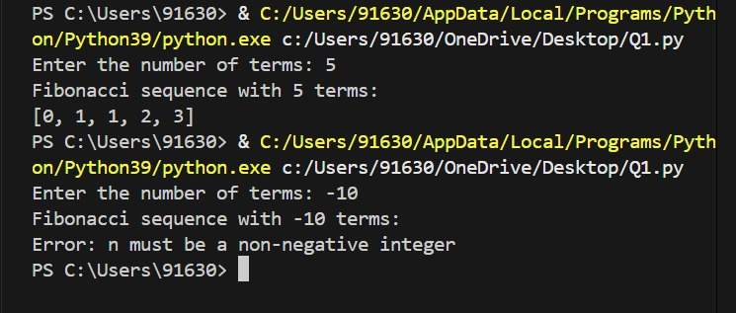

Q2. Write a Python queue class (`enqueue`, `dequeue`, `peek`). Use an AI assistant and test the class with multiple scenarios. Describe how AI-generated code manages edge cases and how you improved it.
Prompt-1: Write a Python class for a queue with enqueue, dequeue, and peek methods.
Priompt-2: Update the queue class to handle empty queue cases gracefully.
Prompt-3: Take input from user.

CODE:
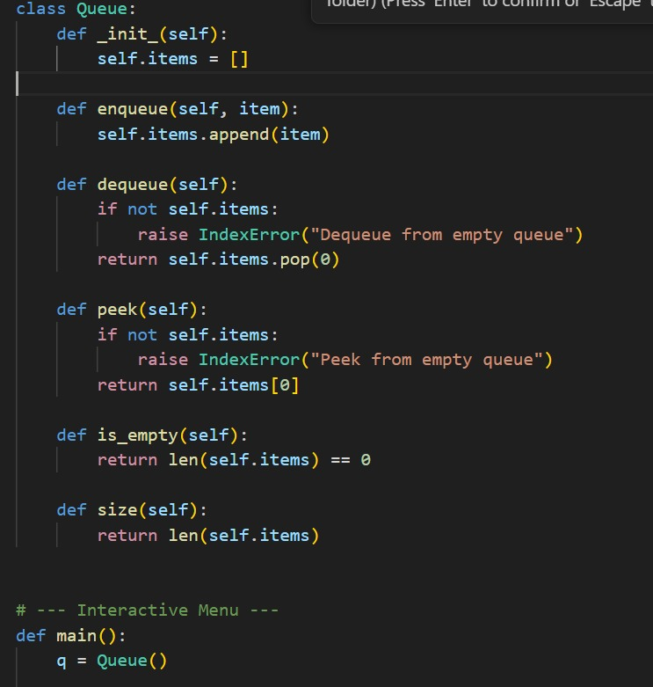
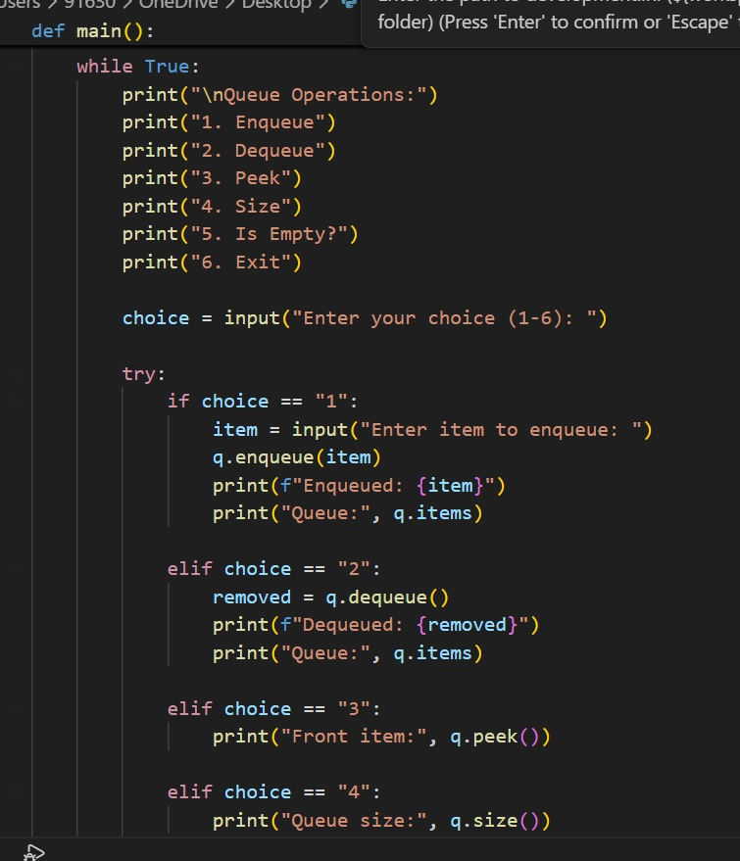

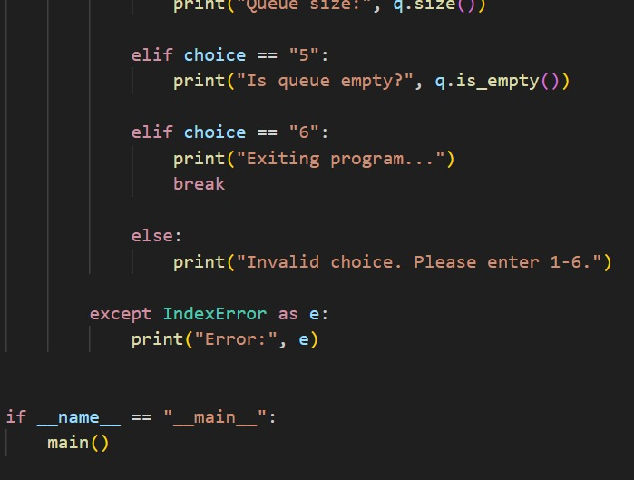

OUTPUT:
